SCREENSHOTS OF VMS

MAIN SCREEN:

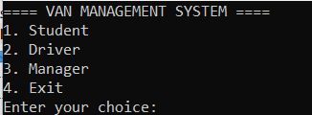

FOLLOWING OUTPUTS ARE FOR MANAGER:

**

*CHOICE 1:*

*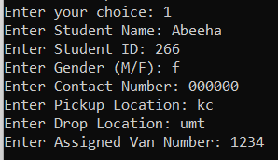*

*CHOICE 2:*

**

*Choice 3:*

*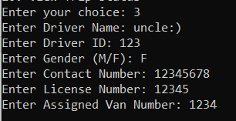*

*Choice 4:*

**

*Choice 5:*

*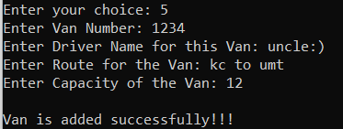*

*Choice 6:*

*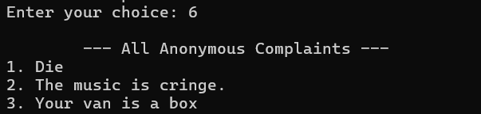*

*Choice 7:*

*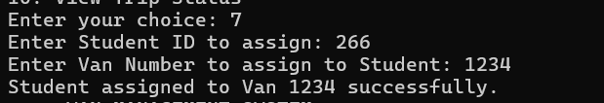*

*Choice 8:*

*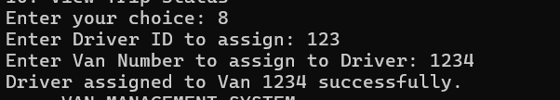*

*Choice 9:*

*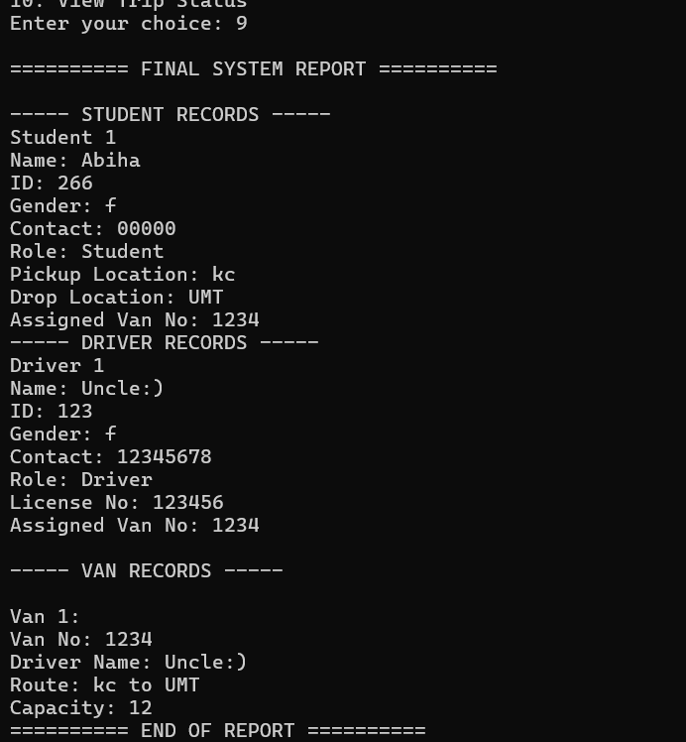*

*Choice 10:*

**

*FOLLOWING OUTPUTS ARE FOR STUDENT:*

**

*Choice 1:*

**

*Choice 2:*

**

*FOLLOWING OUTPUTS ARE FOR DRIVER:*

*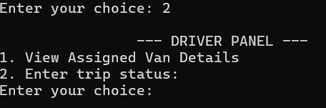*

*Choice 1:*

*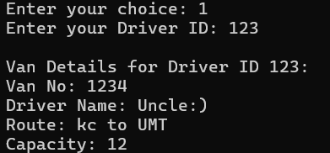*

*Choice 2:*

*